Postal Life Insurance

Department of Post

Software Requirements Specification (SRS)/ Functional Requirements Specification (FRS)
  - Web Portal for Customers

INTERNAL APPROVAL FORM

Project Name: Web Portal for Customers
Version: 1.0
Submitted on:
 | Name | Date
Approved By:
Reviewed By:
Prepared By:

VERSION CONTROL LOG
Version | Date | Prepared By | Remarks
1

Table of Contents

1. Executive Summary 4
2. Project Scope 4
3. Business Requirements 4
4. Functional Requirements Specification 5
4.1 User Onboarding & Login Authentication 7
4.1.1 User Onboarding 8
4.1.2 Login Authentication 8
4.2 Dashboard Page 8
4.3 My Policies Page 9
4.5 Payment Page 11
4.6 Service Request Page 13
4.7 Service Request Tracking Page 13
4.8 Notification & Support Page 15
4.9 Policy Purchase Page 17
4.10 Tools & Utilities Page 17
4.11 My Profile Page 17
5. Appendices 39

1. Executive Summary
The purpose of this document is to define the requirements for the India Post PLI Customer Portal. This portal will enable customers to manage their Postal Life Insurance (PLI) and Rural Postal Life Insurance (RPLI) policies online, providing a seamless, secure, and user-friendly experience.

2. Project Scope
The portal will allow customers to:
- Onboard and authenticate securely.
- View and manage policies.
- Make premium payments.
- Initiate and track claims.
- Request non-financial services.
- Purchase new policies.
- Modify existing policy details.
- Access notifications and support.

3. Business Requirements

Requirement ID | Business Requirement | Description
FS_WPC_001 | Customer Onboarding | The portal shall allow new and existing customers to register using policy details and mobile OTP.
FS_ WPC_002 | Customer Onboarding | The system shall validate customer identity using Aadhaar or other government-approved KYC methods.
FS_ WPC_003 | Secure Login & Authentication | The portal shall provide secure login with username/password and OTP-based multi-factor authentication.
FS_ WPC_004 | Secure Login & Authentication | The system shall support password reset and account recovery mechanisms.
FS_ WPC_005 | Customer Dashboard | The portal shall display a personalized dashboard showing active policies, premium due dates, claim status, and notifications.
FS_ WPC_006 | Customer Dashboard | The dashboard shall provide quick access to key actions like payments and service requests.
FS_ WPC_007 | Premium Payment | The portal shall allow customers to pay premiums online using multiple payment modes (UPI, Net Banking, Cards).
FS_ WPC_008 | Premium Payment | The system shall generate and store digital receipts for each transaction.
FS_ WPC_009 | Claim Initiation | The portal shall allow customers to initiate claims (maturity, death, surrender) by submitting required forms and documents.
FS_ WPC_010 | Claim Initiation | The system shall validate claim eligibility and notify users of next steps.
FS_ WPC_011 | Claim Tracking | The portal shall provide real-time tracking of claim status.
FS_ WPC_012 | Claim Tracking | Customers shall receive automated updates via SMS/email at each stage of claim processing.
FS_ WPC_013 | Notifications and Support | The portal shall send timely notifications for premium due dates, claim updates, and service request status.
FS_ WPC_014 | Notifications and Support | The system shall include a support module with chatbot, FAQs, and ticket-based query resolution.
FS_ WPC_015 | New Policy Purchase Initiation | The portal shall allow customers to explore and initiate purchase of PLI/RPLI policies.
FS_ WPC_016 | New Policy Purchase Initiation | The system shall generate premium quotes based on user inputs and policy type.
FS_ WPC_017 | Policy Purchase Finalization | The portal shall facilitate scheduling of medical tests (if required) and submission of final documents.
FS_ WPC_018 | Policy Purchase Finalization | The system shall issue policy documents upon successful verification and approval.
FS_ WPC_019 | Non-Financial Service Requests – Type A | The portal shall allow submission of service requests that require physical verification at a post office.
FS_ WPC_020 | Non-Financial Service Requests – Type A | The system shall track and update the status of such requests.
FS_ WPC_021 | Non-Financial Service Requests – Type B | The portal shall allow submission of service requests authenticated via OTP (e.g., mobile/email update).
FS_ WPC_022 | Non-Financial Service Requests – Type B | The system shall process and confirm such requests instantly.
FS_ WPC_023 | Policy Commutation | The portal shall allow customers to request changes to premium amount, premium term, or sum assured.
FS_ WPC_024 | Policy Commutation | The system shall validate requests against underwriting rules and notify customers of approval or rejection.
FS_ WPC_025 | Policy Conversion | The portal shall allow eligible customers to convert their policy type.
FS_ WPC_026 | Policy Conversion | The system shall guide users through the conversion process and update policy records accordingly.
FS_ WPC_027 | Session & Security Management | The portal shall implement secure session management with automatic logout on inactivity.
FS_ WPC_028 | Session & Security Management | The system shall encrypt sensitive data and maintain an audit trail of all user actions.

4. Functional Requirements Specification
Flow for the Web Portal for Customers:
- Primary Actions before Login:
  - User Onboarding (User icon)
  - Login Authentication (Lock icon)
- Dashboard: Display to Customer After Login
- Main Features in Dashboard:
  - My Policies Page
  - Payment Page
    - Premium Payment
    - Repay Full Loan
    - Repay Partial Loan
    - Payment History
    - Income Tax Certificate
  - Service Requests Page
    - Claim Initiation
    - Claim Tracking
    - Non-Financial Service Requests Type A (Post Office Verification)
    - Non-Financial Service Requests Type B (OTP Authentication)
    - Policy Commutation (Premium Amount, Term, Sum Assured)
    - Policy Conversion
  - Service Requests Tracking Page
  - Notification & Support Page
  - Policy Purchase Page
    - Illustration
    - Quote
    - New Policy Purchase Initiation
    - Policy Purchase Medical & Finalization
    - Proposal Tracking
    - Initial Premium Payment
    - Upload Documents
  - Tools & Utilities Page
    - Request an Agent
    - Locate an Agent
    - Download Forms and Documents
    - Guidelines for Customers
    - Customer Grievance
    - Escalation Matrix
    - Submit Query
    - Service Request Documents
    - Privacy Policy
  - My Profile Page
    - Change Password

4.1 User Onboarding & Login Authentication
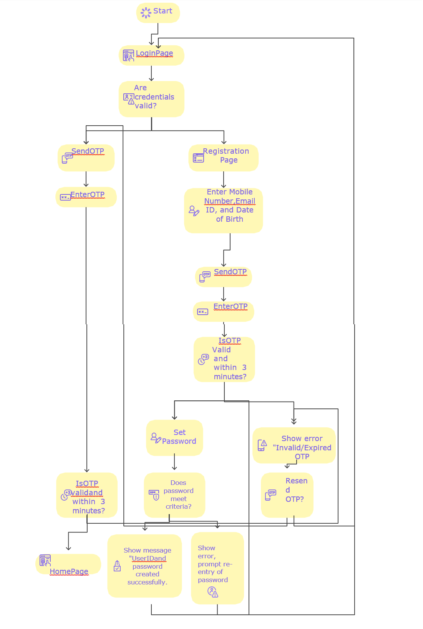

4.1.1 User Onboarding
- Purpose: Allow new and existing customers to register.
- Fields:
  - Policy Number: Customer’s existing policy number for validation.
  - Name: Full name as per policy records.
  - Date of Birth: For identity verification.
  - Mobile Number: Used for OTP verification.
  - Email ID: For communication and notifications.
  - Aadhaar / KYC Details: Government-approved identity verification.
- Details: Integration with KYC APIs for validation.

4.1.2 Login Authentication
- Purpose: Authenticate customers securely before accessing the portal.
- Fields:
  - Username / Policy Number: Unique identifier for the customer.
  - Password: Secret key for authentication.
  - OTP: One-time password for multi-factor authentication.
- Details: Includes “Forgot Password” and “Register” links.

4.2 Dashboard Page
- Purpose: This is the page that gets displayed to user after successful login.
- Fields:
  - My Policies (Document icon)
  - Payment (₹ icon)
  - Service Requests (Gear icon)
  - Notification & Support (Bell icon)
  - Service Requests Tracking (Checklist icon)
  - Policy Purchase (Document icon)
  - Tools & Utilities (Tools icon)
  - My Profile (User icon)

Wireframe for the Dashboard Page:
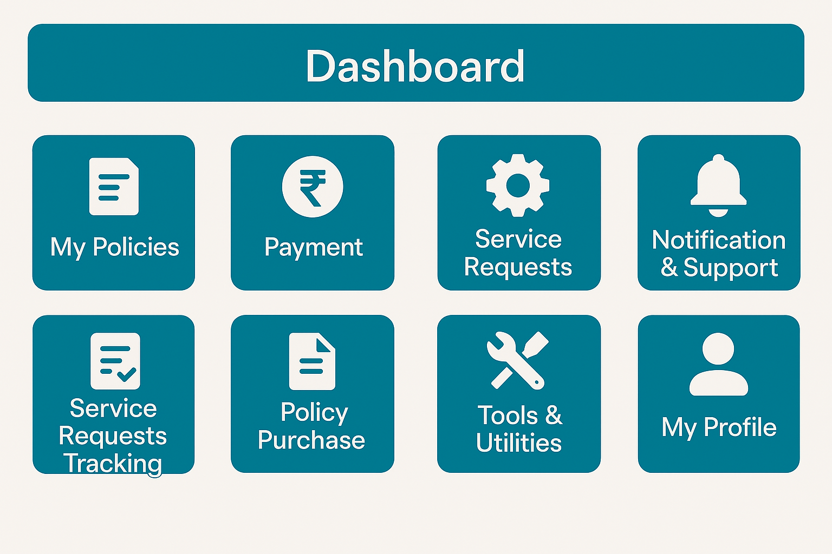

4.3 My Policies Page
- Purpose: Show details of all active policies.
- Fields:
- Policy Number: Unique identifier for each policy.
- Policy Type: Type of policy (PLI/RPLI).
- Sum Assured: Coverage amount.
- Premium Amount: Regular payment amount.
- Next Due Date: Upcoming premium payment date.
- Details: Option to download policy documents.

4.5 Payment Page
- Purpose: Enable premium and loan repayments.
- Fields:
  - Policy Number: Policy for which payment is being made.
  - Amount Due: Total payable amount.
  - Payment Mode: UPI, Net Banking, Credit/Debit Card.
- Details: Generates digital receipt and updates payment history.
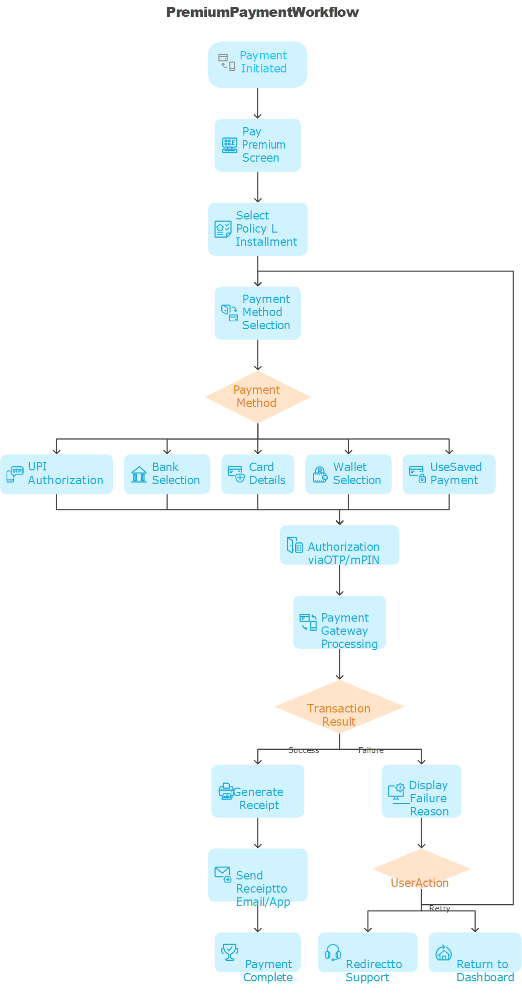

4.6 Service Request Page
- Purpose: Submit financial and non-financial requests.
- Fields:
  - Request Type: Claim, Policy Commutation, Conversion, etc.
  - Policy Number: Associated policy for the request.
  - Supporting Documents Upload: Required documents for processing.
- Details: OTP authentication for Type B requests.

4.7 Service Request Tracking Page
- Purpose: Track status of submitted requests.
- Fields:
  - Request ID: Unique identifier for each request.
  - Status: Pending, Approved, Rejected.
  - Last Updated Date: Timestamp of last update.
- Details: Real-time updates and SMS/email notifications.

4.8 Notification & Support Page
- Purpose: Provide alerts and customer assistance.
- Fields:
  - Notifications List: Premium due, claim updates, service status.
  - Chatbot / FAQ: Automated help and common queries.
  - Raise Ticket: Submit detailed query for resolution.
- Details: Includes escalation matrix and grievance redressal.

4.9 Policy Purchase Page
- Purpose: Explore and buy new policies.
- Fields:
  - Policy Type: Select PLI/RPLI product.
  - Age, Sum Assured, Term: Inputs for premium calculation.
  - Quote & Illustration: Generated based on inputs.
- Details: Upload documents, schedule medical tests, track proposal.

4.10 Tools & Utilities Page
- Purpose: Provide additional resources.
- Fields:
  - Request Agent: Submit request for agent assistance.
  - Locate Agent: Find nearest agent by PIN code.
  - Download Forms: Access policy-related forms.
  - Submit Query: Raise general queries.
- Details: Includes Privacy Policy and Customer Guidelines.

4.11 My Profile Page
- Purpose: Manage personal details.
- Fields:
  - Name: Editable if allowed.
  - Mobile Number: Update with OTP verification.
  - Email: Update for communication.
  - Change Password: Secure password update.
- Details: All changes logged for audit.

Part 1: New PLI Policy Purchase Flow - Application & Eligibility
NEW PLI POLICY PURCHASE FLOW - PART 1/2: APPLICATION & ELIGIBILITY
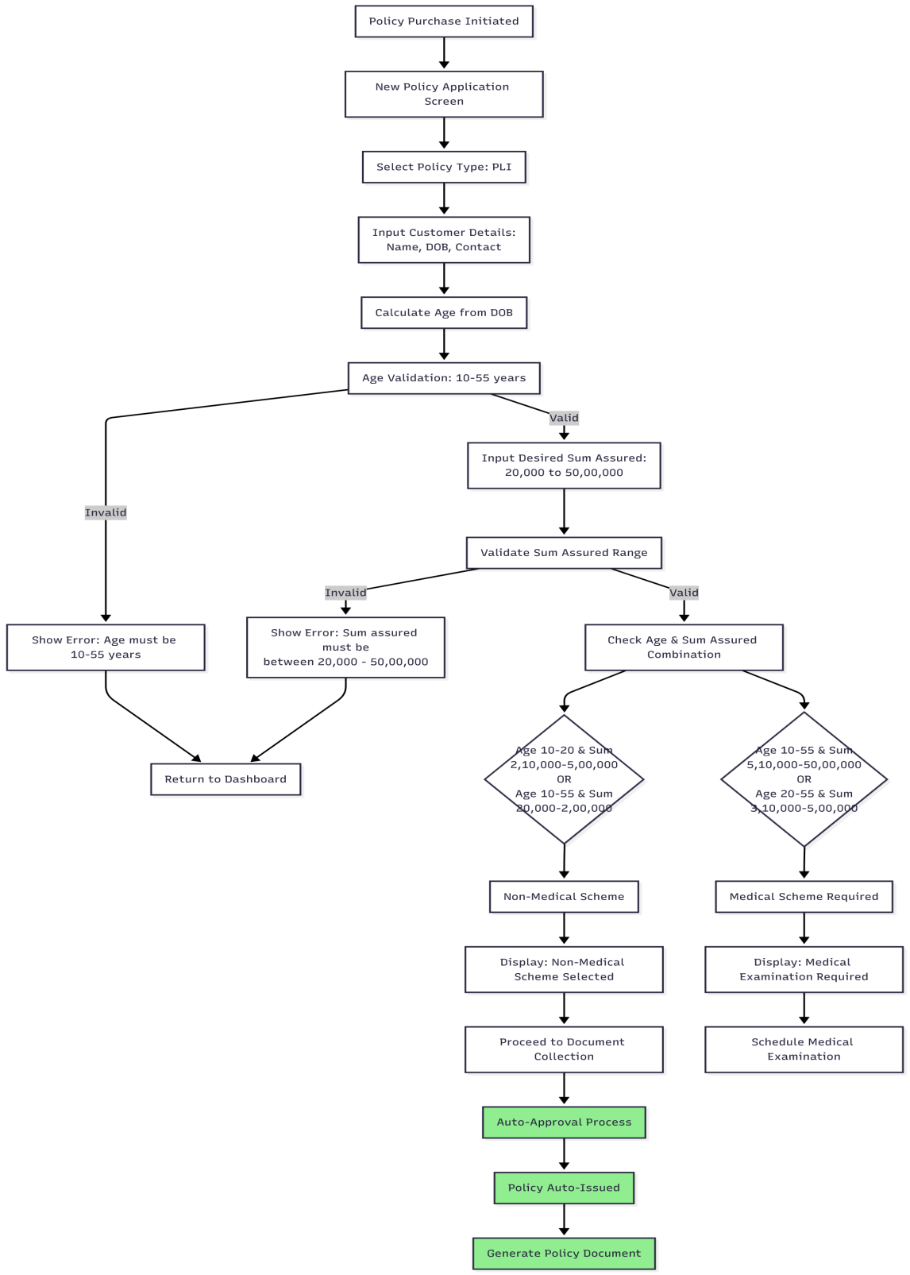
Part 2: New PLI Policy Purchase Flow - Medical & Finalization
NEW PLI POLICY PURCHASE FLOW - PART 2/2: MEDICAL & FINALIZATION
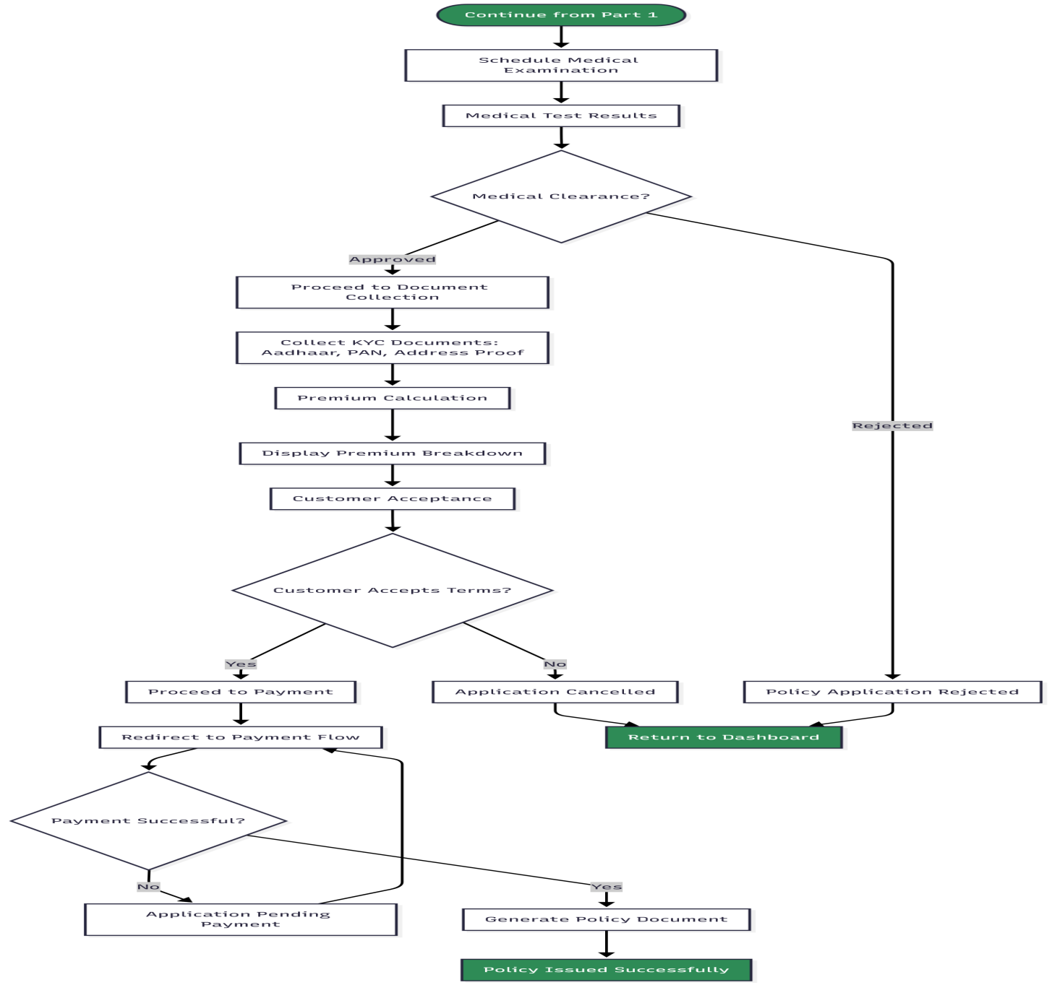

Medical Requirement Decision Matrix (For Reference)
PLI MEDICAL REQUIREMENT MATRIX
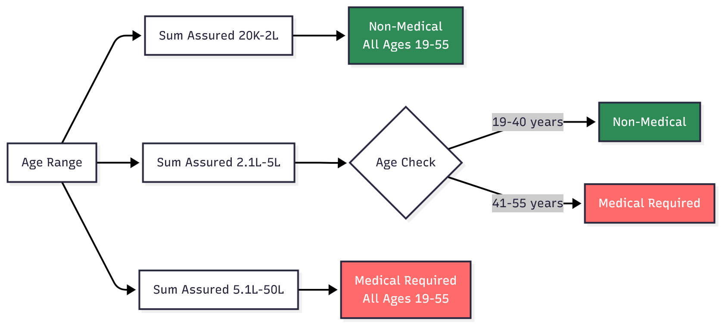

Part 1: New RPLI Policy Purchase Flow - Application & Rural Validation
NEW RPLI POLICY PURCHASE FLOW - PART 1/2: APPLICATION & RURAL VALIDATION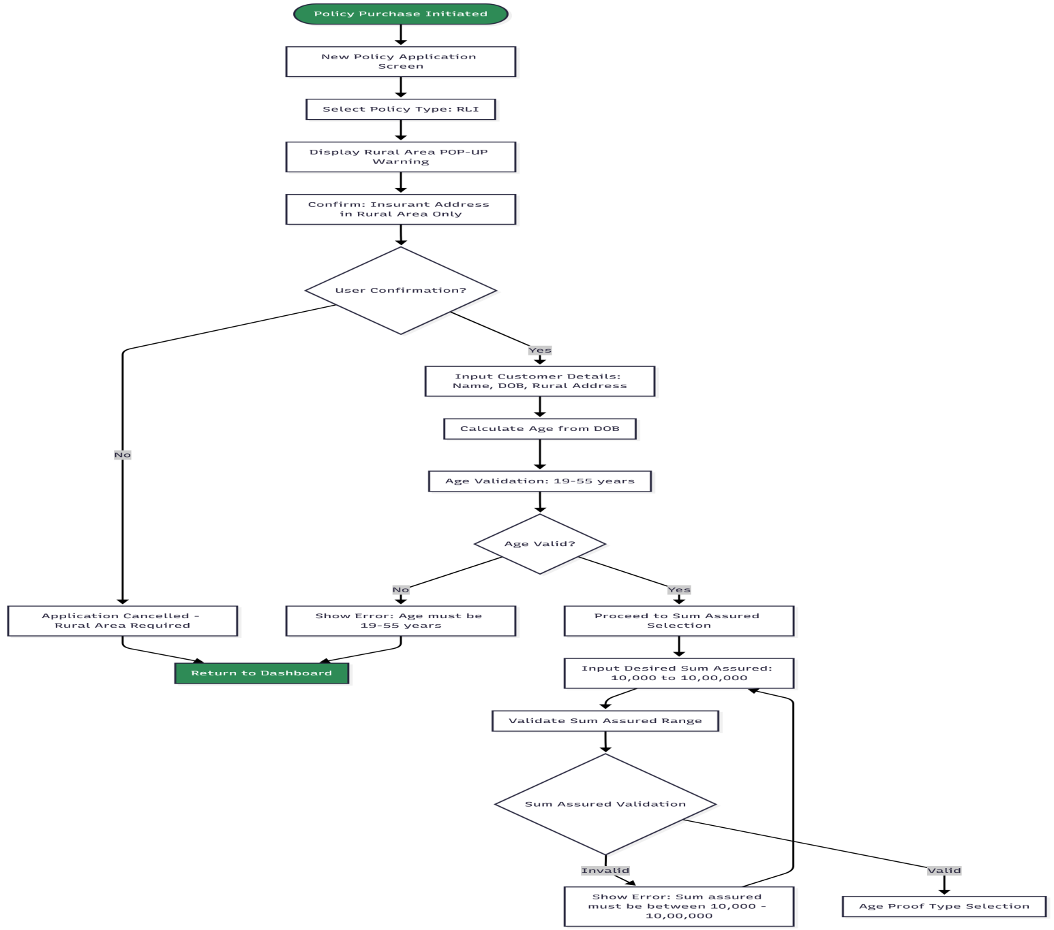

Part 2: New RPLI Policy Purchase Flow - Age Proof & Medical Requirements
NEW RPLI POLICY PURCHASE FLOW - PART 2/2: AGE PROOF & MEDICAL REQUIREMENTS
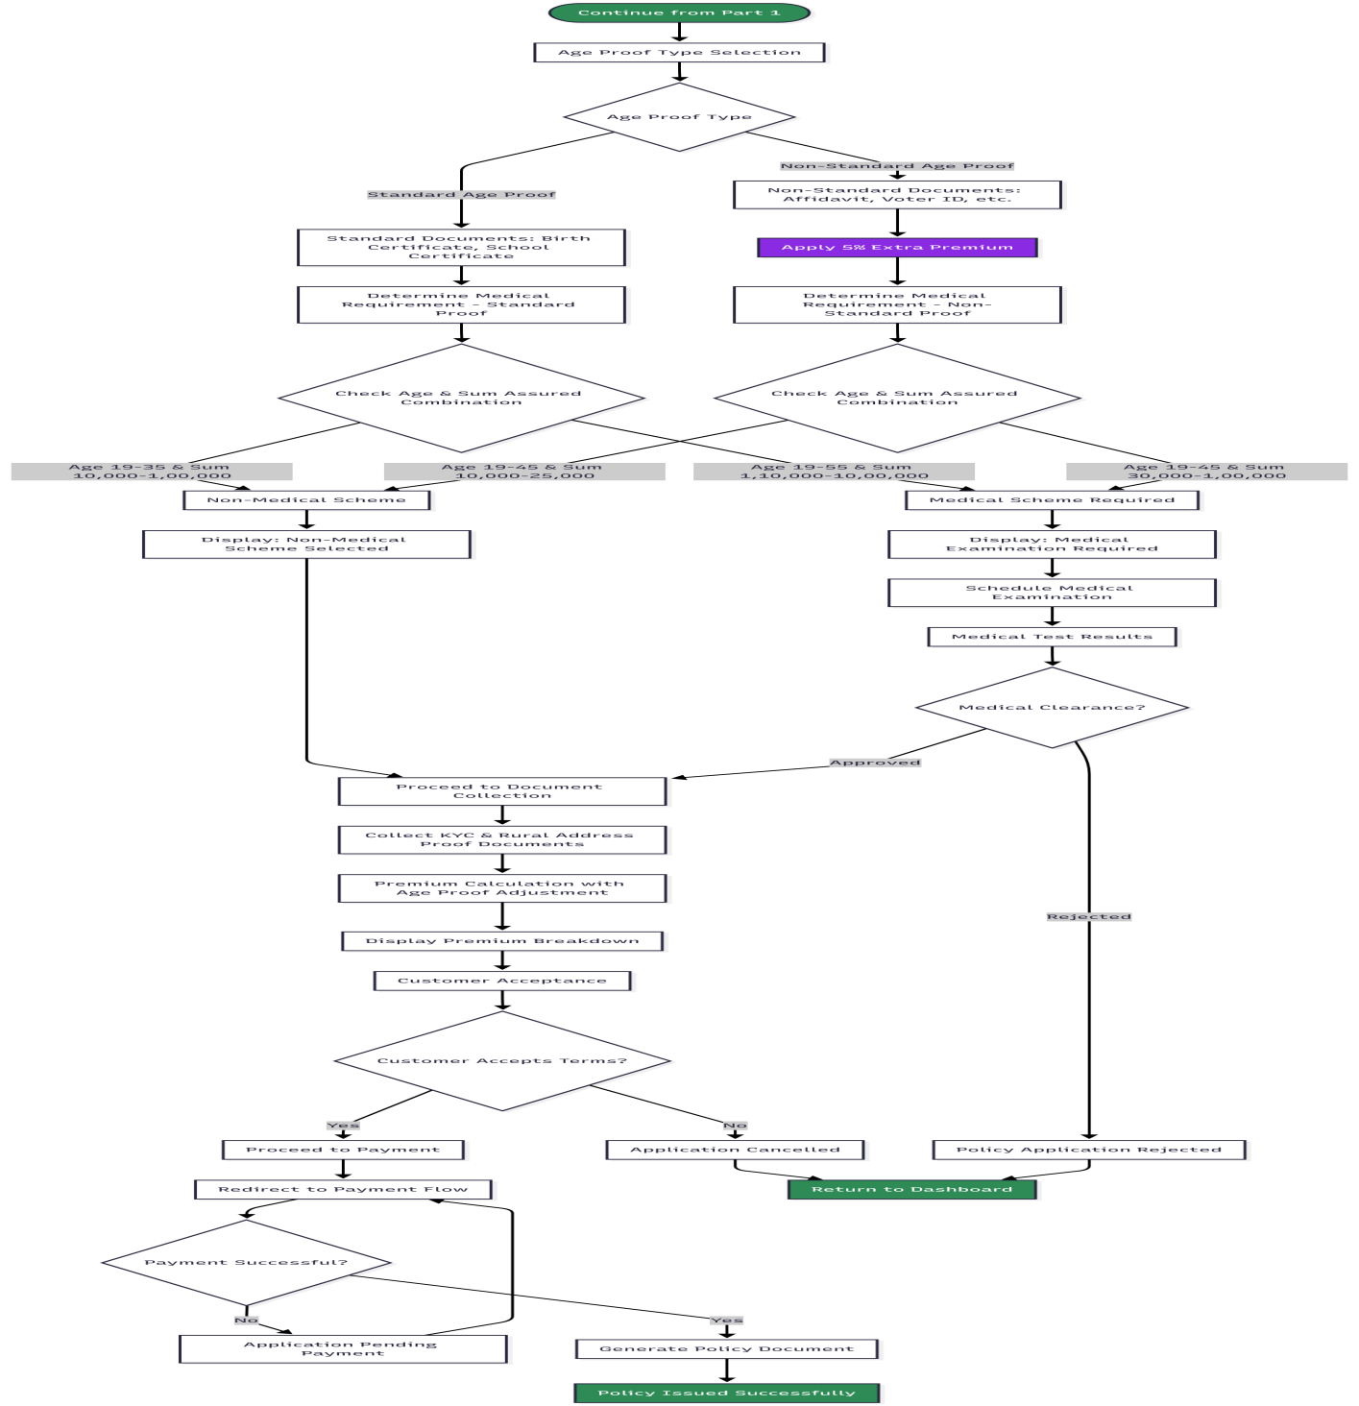

PLI Medical Requirement Decision Matrix (For Reference)
RPLI MEDICAL REQUIREMENT MATRIX
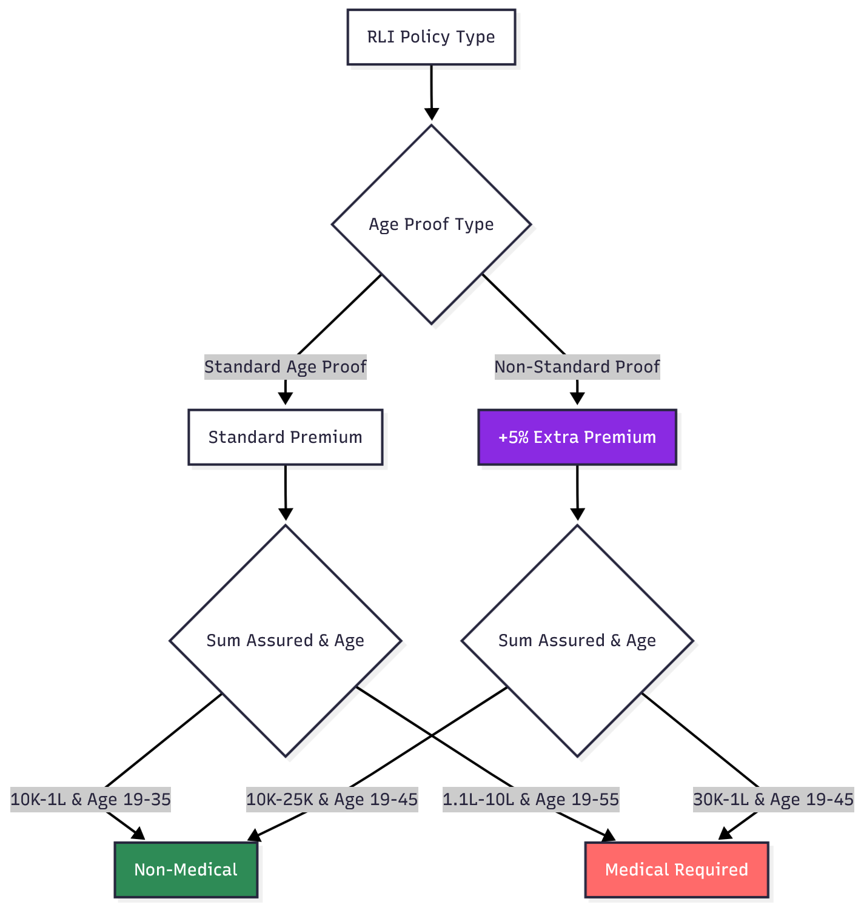

1. Non-Financial Service Requests - Type A (Post Office Verification Required)

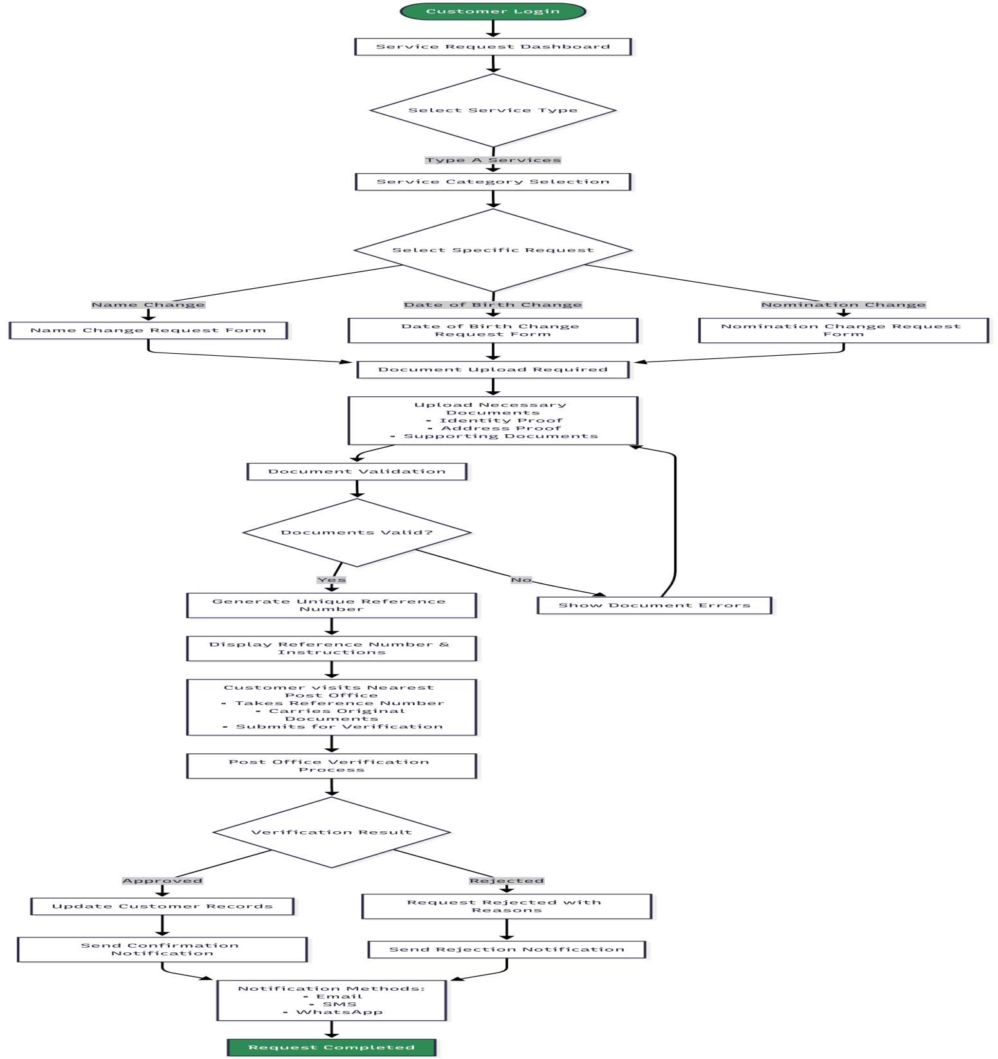

2. Non-Financial Service Requests - Type B (OTP Authentication Only)

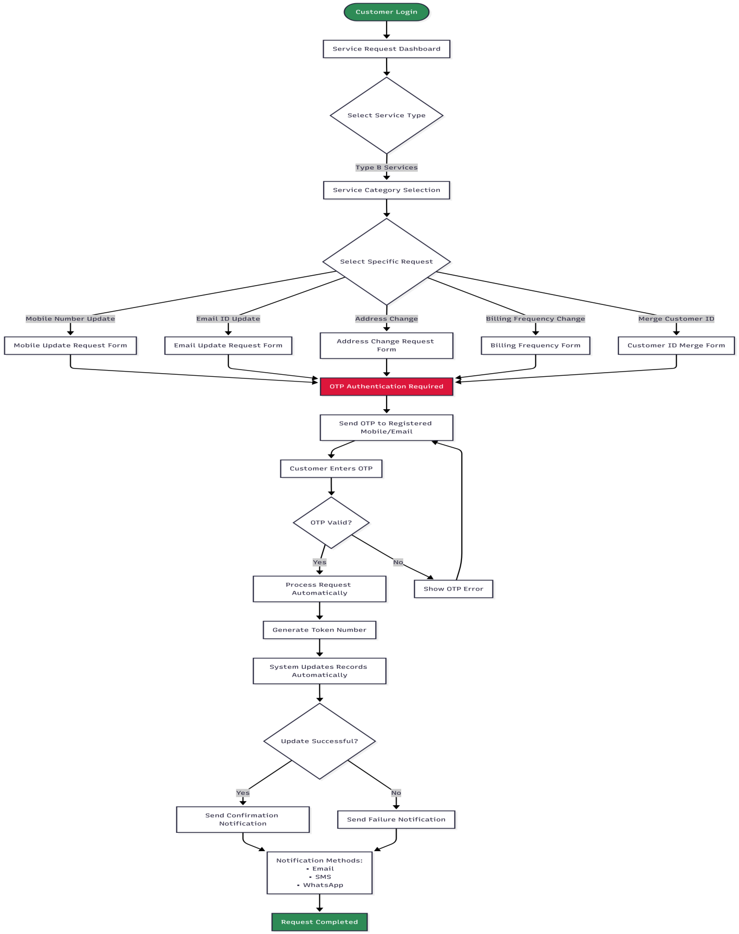
Part 1: Claims Initiation & Eligibility Check
CLAIMS FLOW - PART 1: INITIATION & ELIGIBILITY
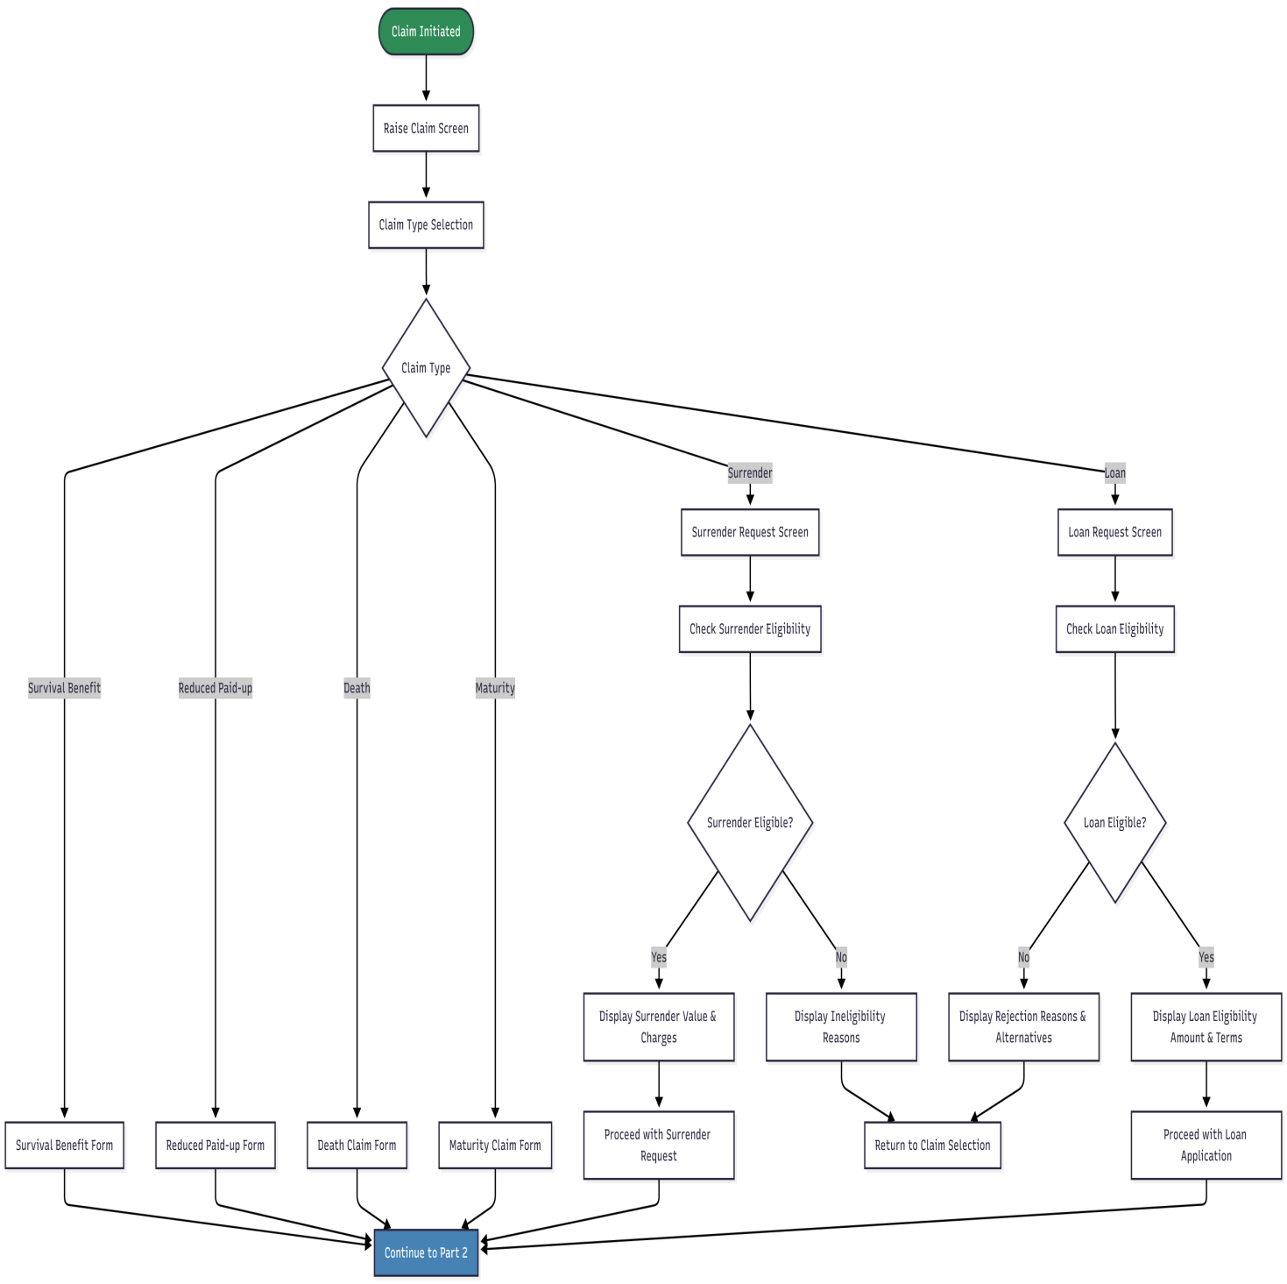

Part 2: Bank Details Verification & Document Upload
CLAIMS FLOW - PART 2: BANK VERIFICATION & DOCUMENTS
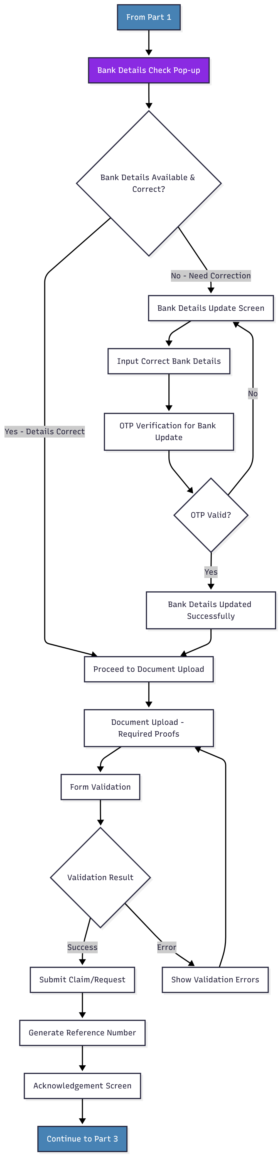

Part 3: Notifications & Tracking
CLAIMS FLOW - PART 3: NOTIFICATIONS & TRACKING
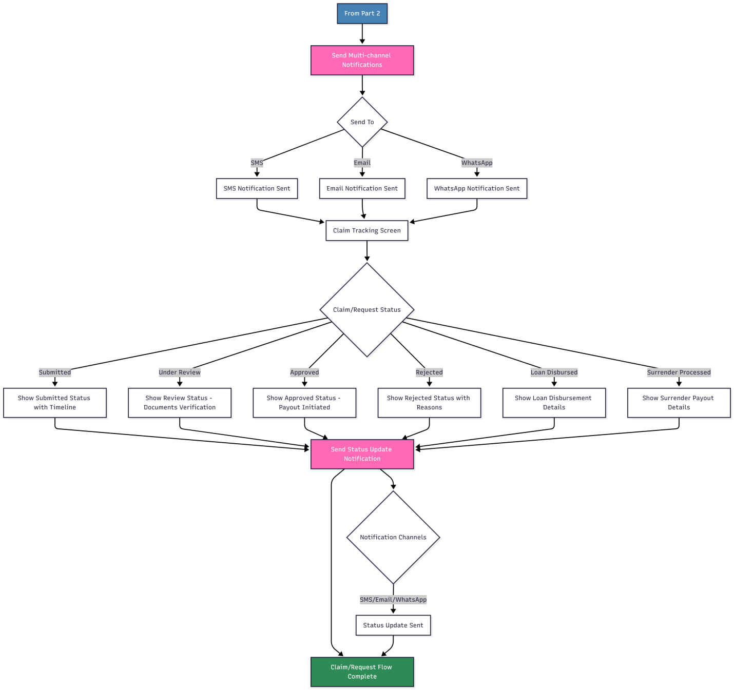

Part 1: PLI Policy Commutation - Contract Alteration Eligibility
PLI POLICY COMMUTATION FLOW - PART 1/4: CONTRACT ALTERATION ELIGIBILITY
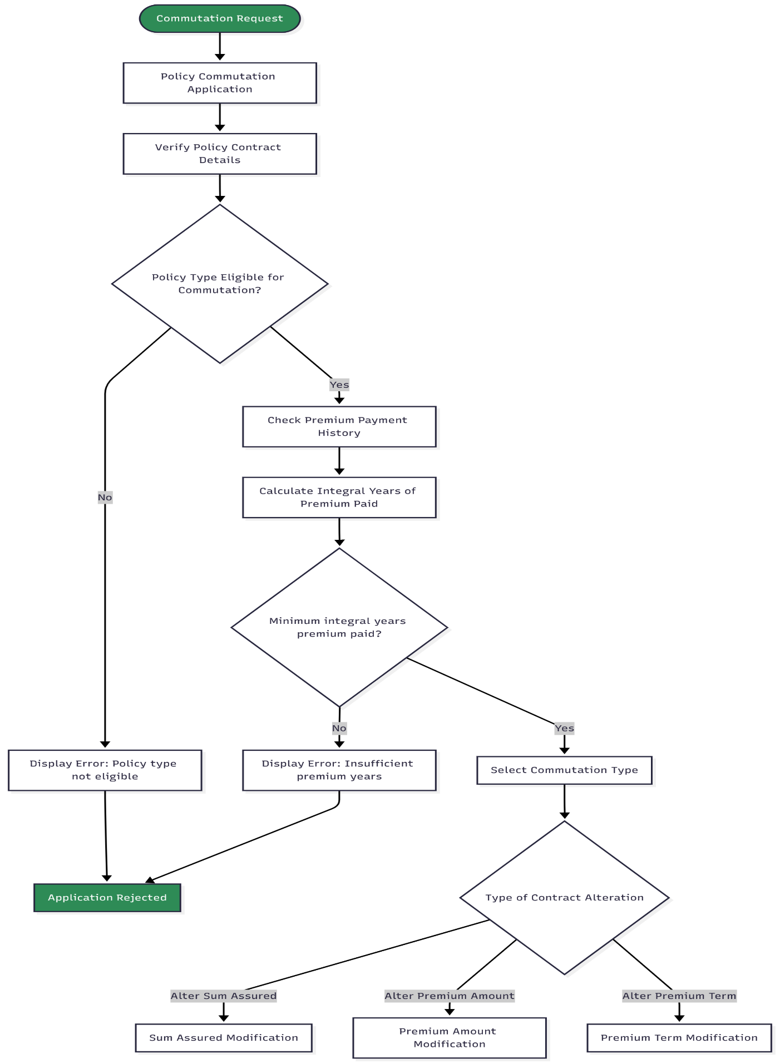
Part 2: PLI Policy Commutation - Alteration Type Processing
PLI POLICY COMMUTATION FLOW - PART 2/4: ALTERATION TYPE PROCESSING
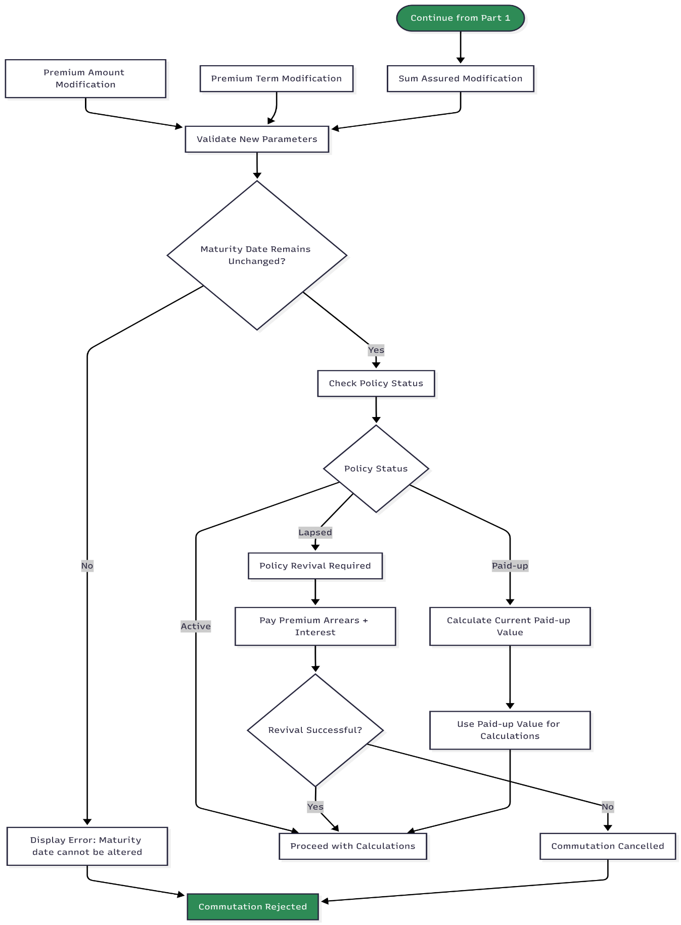
Part 3: PLI Policy Commutation - Financial Calculations & Validation
PLI POLICY COMMUTATION FLOW - PART 3/4: FINANCIAL CALCULATIONS
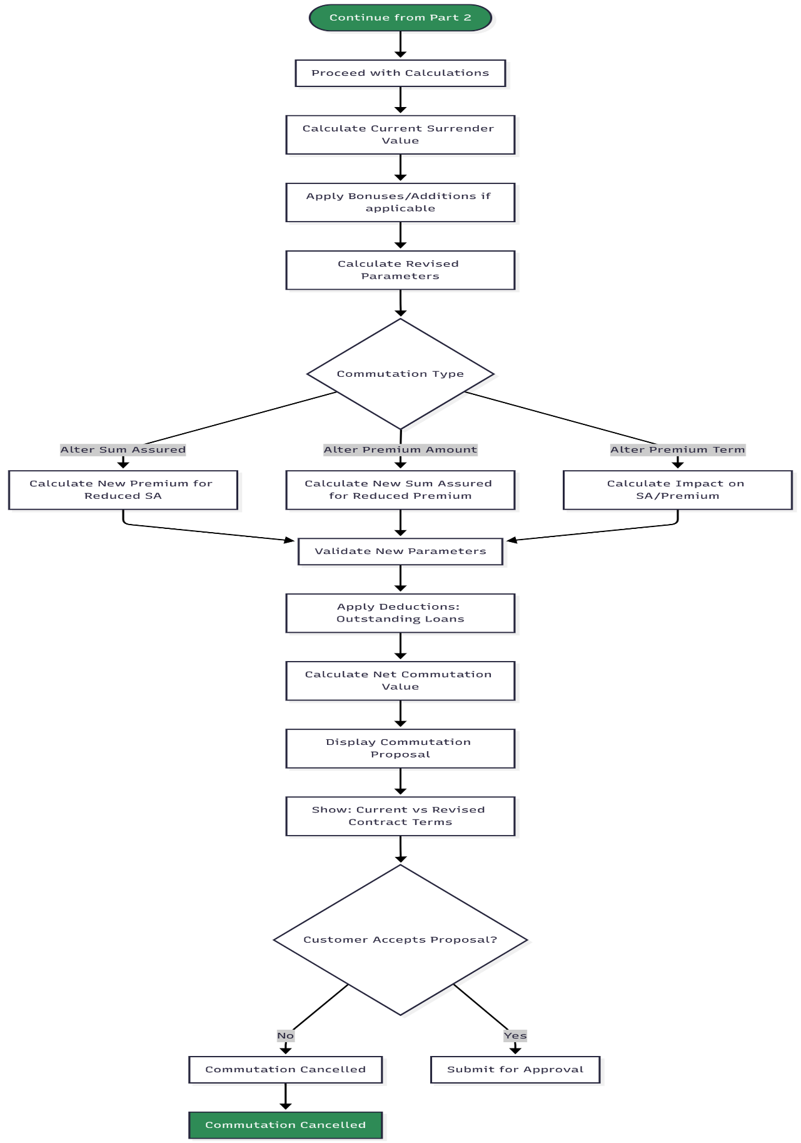
Part 4: PLI Policy Commutation - Approval & Contract Update
PLI POLICY COMMUTATION FLOW - PART 4/4: APPROVAL & UPDATES
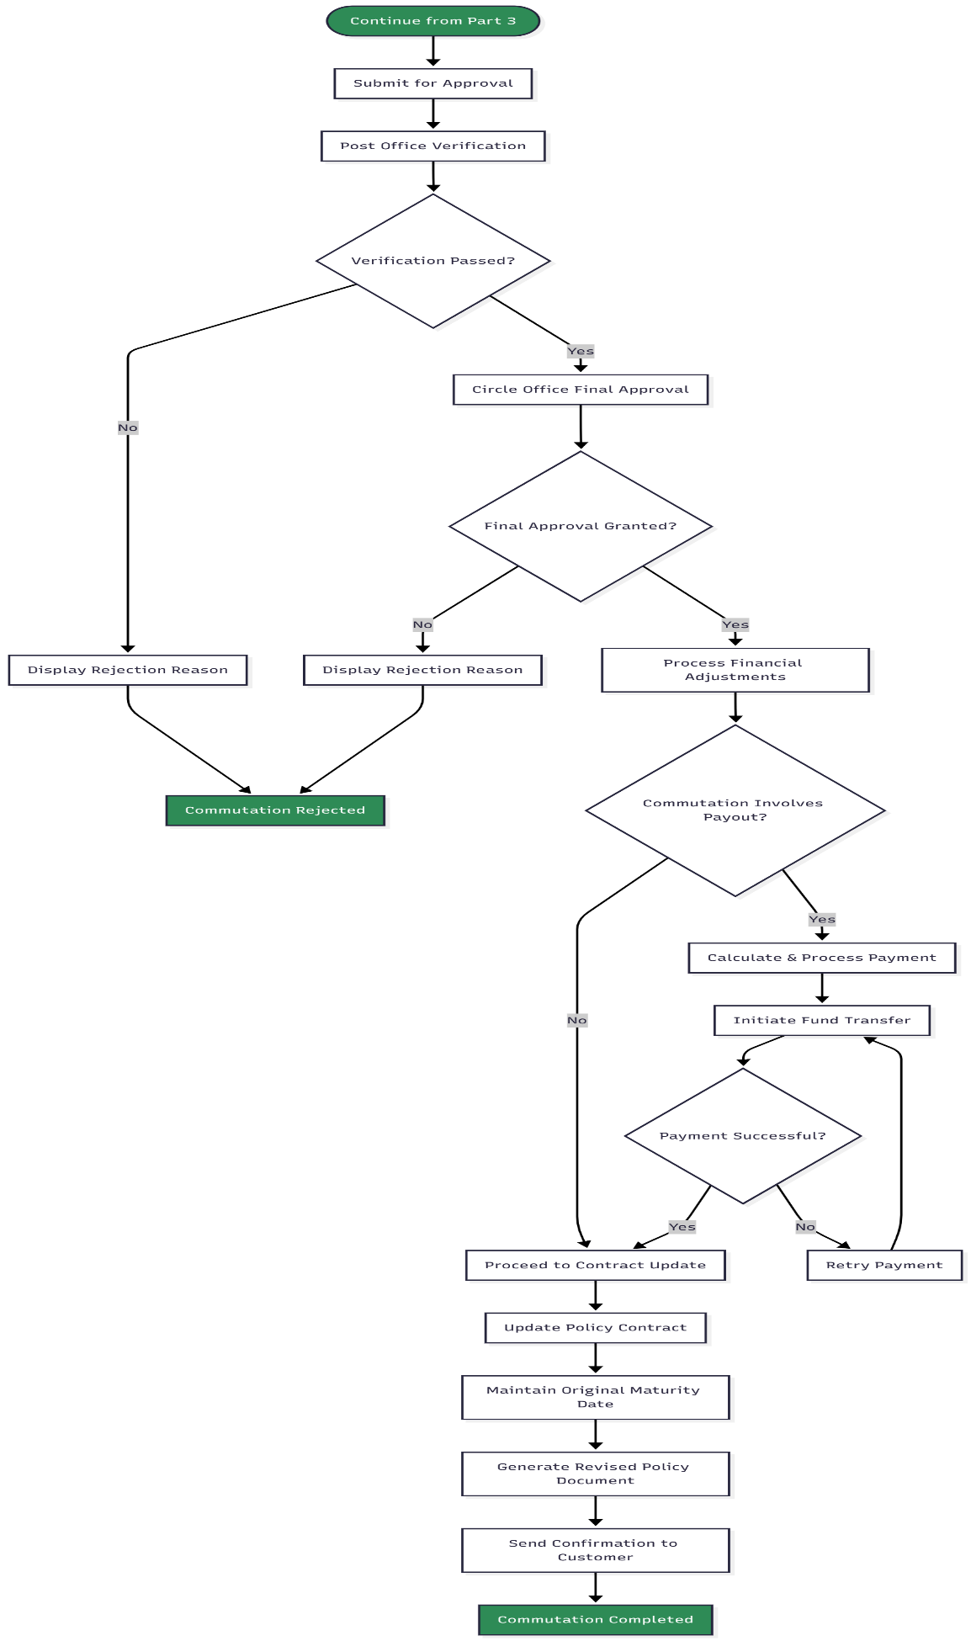
PLI Commutation Rules Summary (For Reference)
COMMUTATION TYPES MATRIX
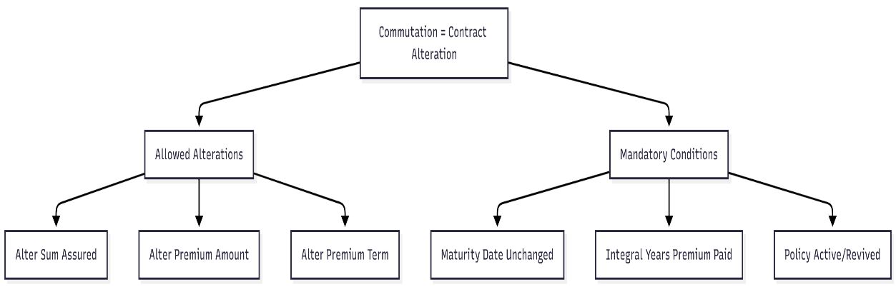

Part 1: PLI Policy Conversion - Eligibility & Type Selection
PLI POLICY CONVERSION FLOW - PART 1/4: ELIGIBILITY & TYPE SELECTION
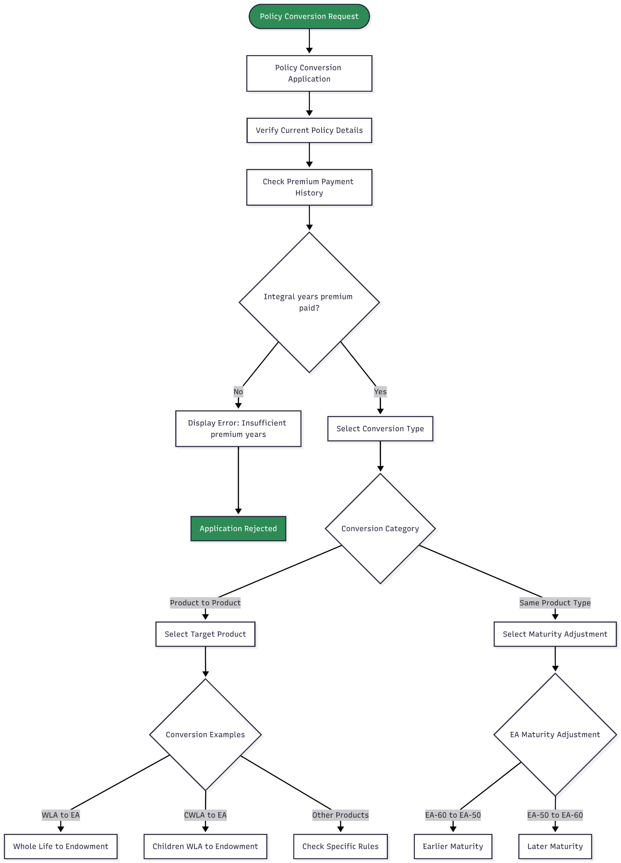
Part 2: PLI Policy Conversion - Maturity Date & Medical Check
PLI POLICY CONVERSION FLOW - PART 2/4: MATURITY & MEDICAL REQUIREMENTS
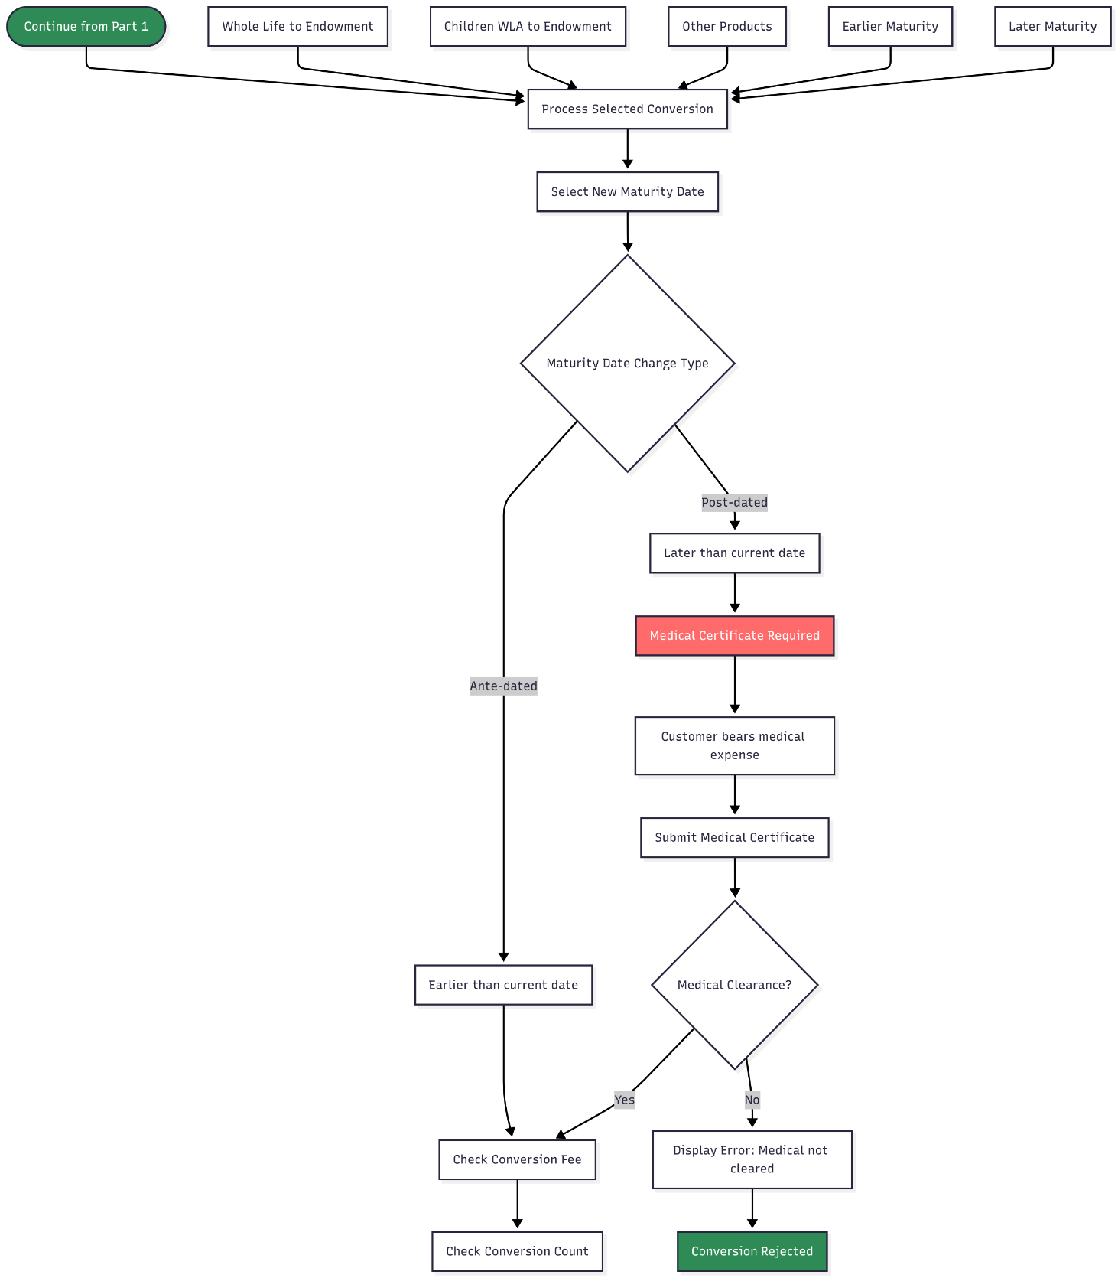

Part 3: PLI Policy Conversion - Fee Calculation & Bonus Treatment
PLI POLICY CONVERSION FLOW - PART 3/4: FEE & BONUS CALCULATIONS
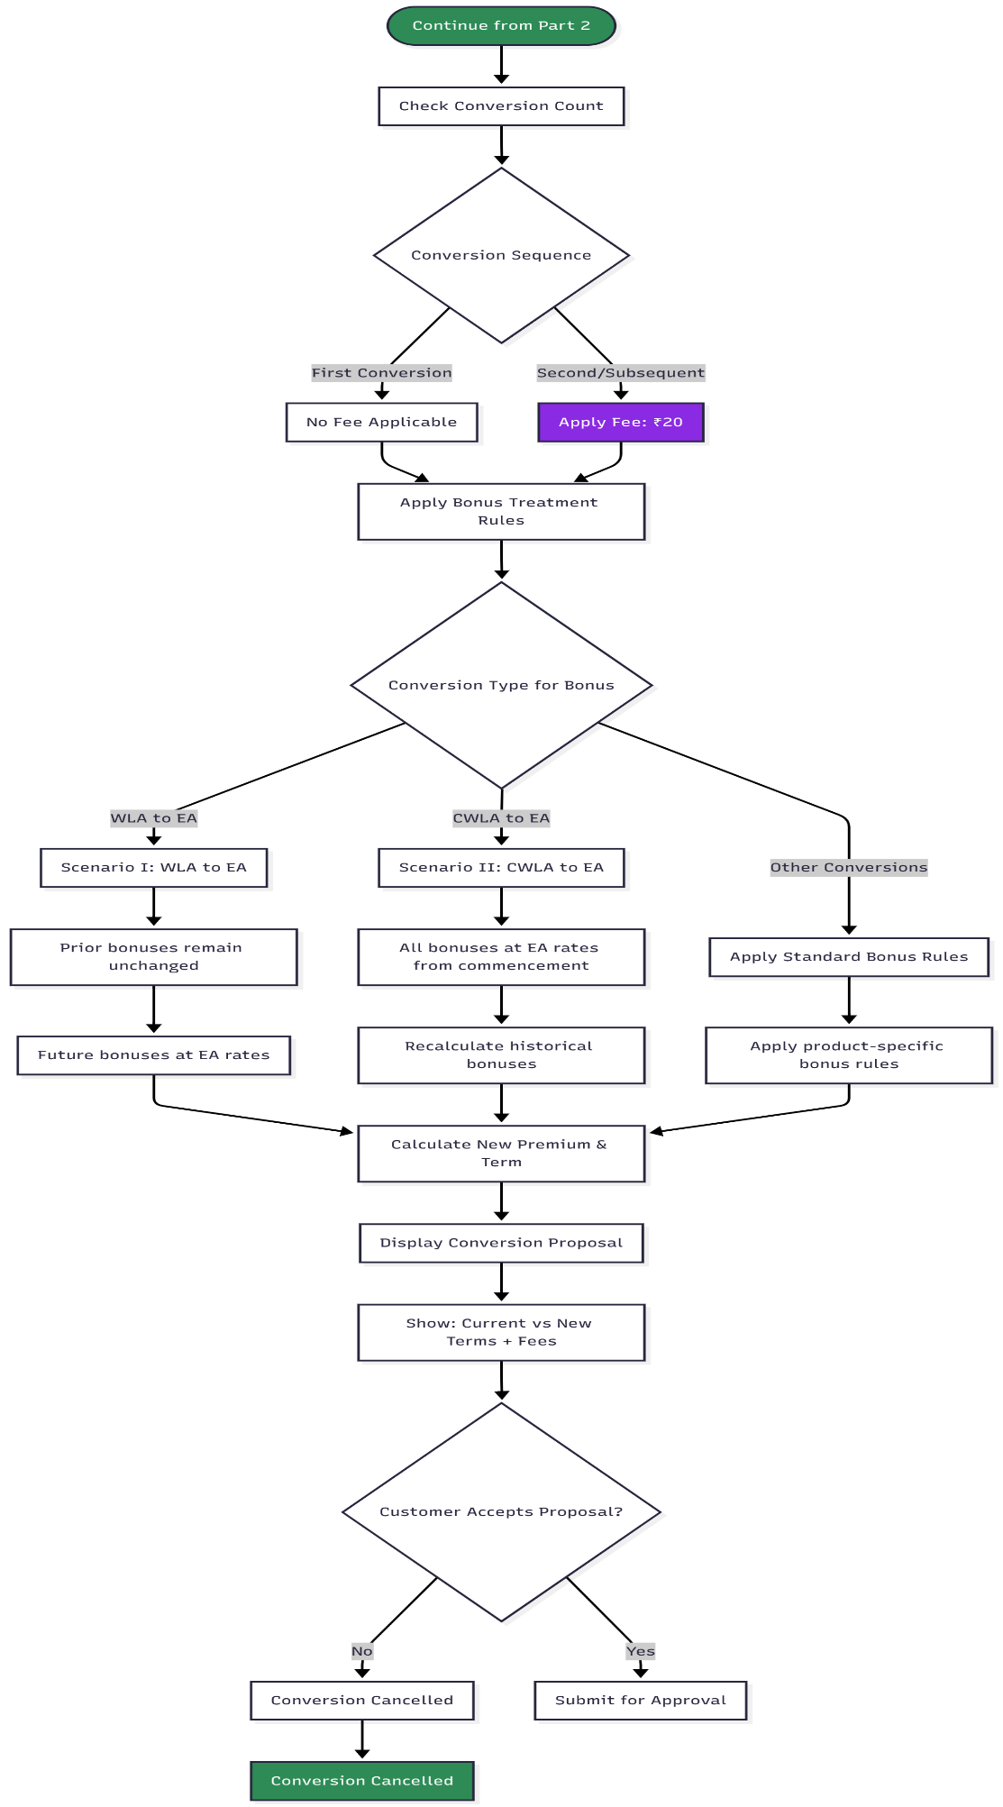
Part 4: PLI Policy Conversion - Approval & Policy Update
PLI POLICY CONVERSION FLOW - PART 4/4: APPROVAL & IMPLEMENTATION
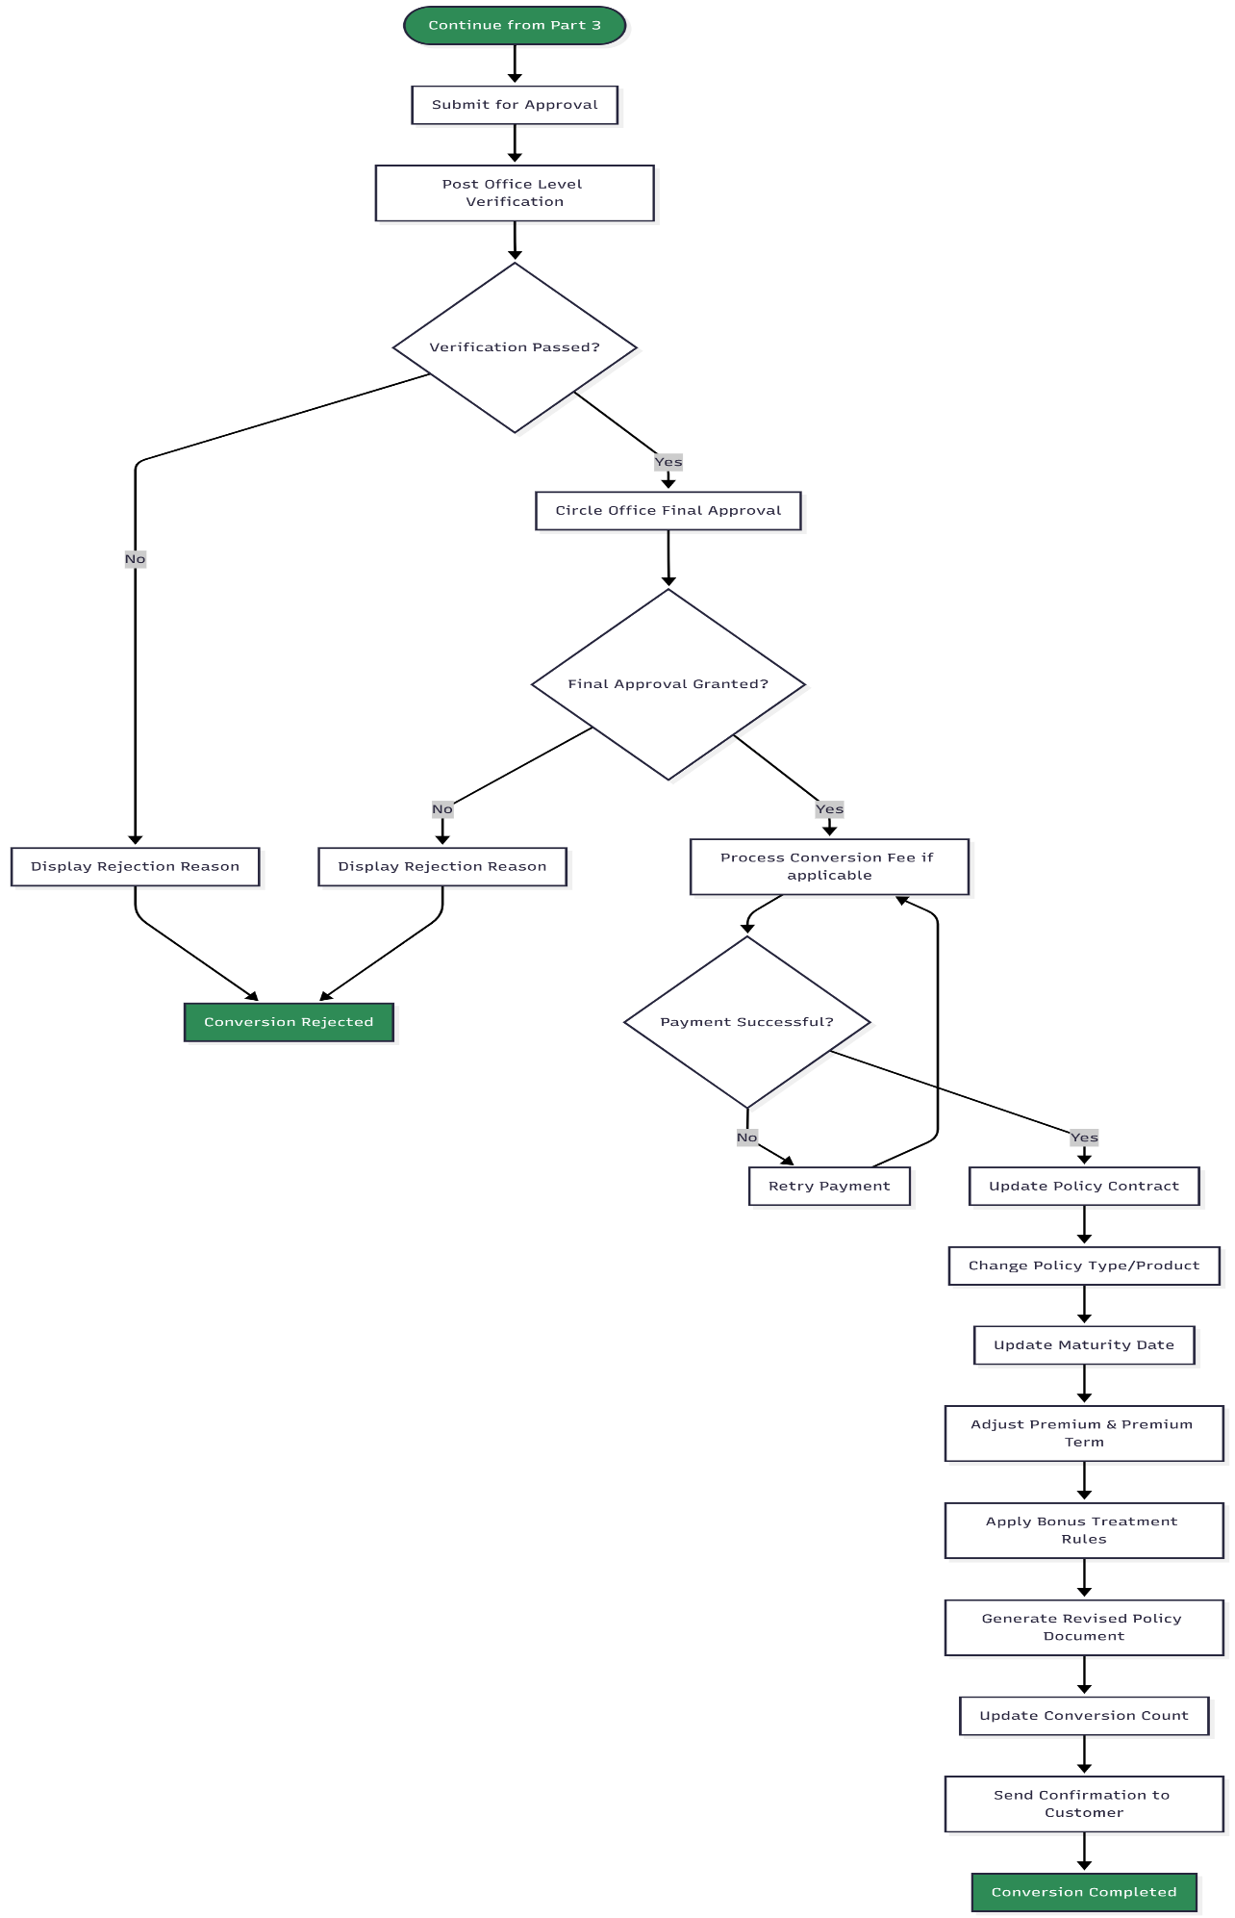
PLI Conversion Rules Summary (For Reference)
CONVERSION TYPES MATRIX
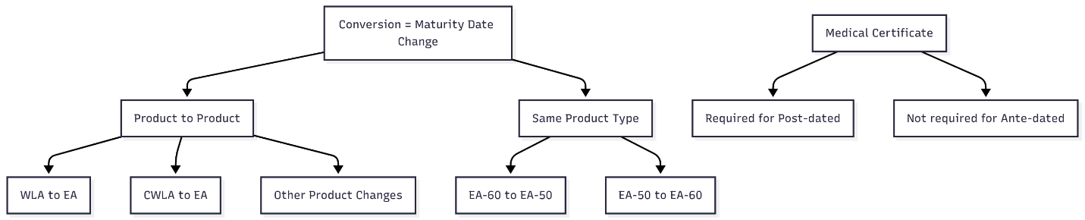

Security & Session Management Flow chart:
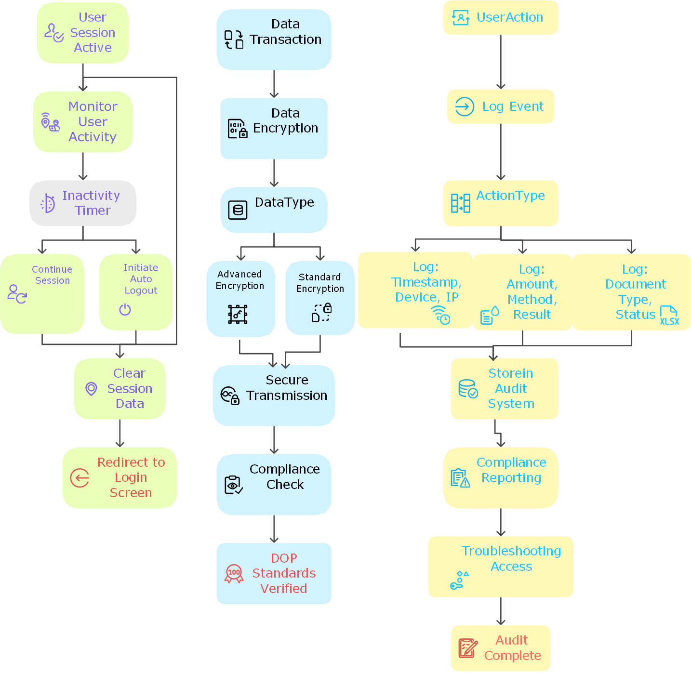

5. Appendices
The Following Documents attached below can be used.

